2015-IL-01 Fuel Way
0 ---- | I: | II: | III: hard | IV: ----

Answer Type: Multiple Choice Mandatory for: none
0: 8-10 years I: 10-12 years II: 12-14 years III: 14-16 years IV: 16-19 years

Body

Yossi want to arrive home from Eric apartment (start point)
Unfortunately he has fuel enough for 10 Miles.
According to the map there are some cities that hold fuel for the trip of X miles and may be added to the fuel tank.

Question
What path he should choose if he want to arrive home?

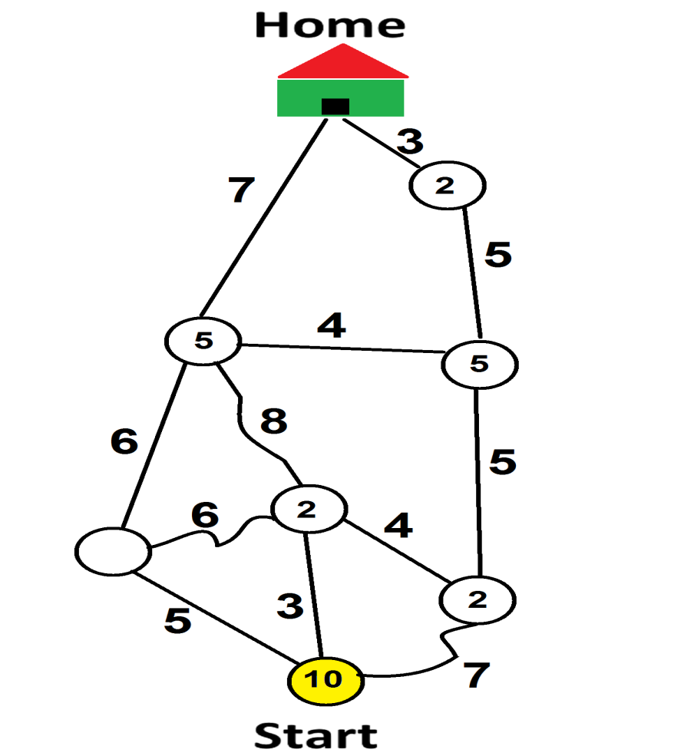

Answer

- 3 8 4 5 3
- 7 5 5 3
- 3 4 5 4 7
- 3 4 5 5 3

Explanation

Correct answer is a.

First step : 10-3 = 7 +2 = 9
Second step : 9-8 = 1 +5 = 6
Third step : 6-4 = 2 +5 = 7
Fourth step : 7-5 = 2 +2 = 4
Fifth step : 4-3 = 1 arriving to Home

In all others cases he will have no fuel somewhere between cities

It's informatics

It is classic graph problem.

Keywords

network, graph

Websites

Internal Use

Wording

Comments

Averbuch Haim averbuchhaim@gmail.com 2014-06-17.

You can use the following map

Graphics

Files

2014-IL-01-GR
2014-IL-01-GR-Color

Authorship

Averbuch Haim Israel averbuchhaim@gmail.com

License

Copyright © 2014 Bebras – International Contest on Informatics and Computer Fluency. This work is licensed under a Creative Commons Attribution-NonCommercial-ShareAlike 3.0 Unported License (CC BY-NC-SA 3.0). Visit: http://creativecommons.org/licenses/by-sa-sa/3.0/

2015-IL-01 Fuel Way
0 ---- | I: | II: | III: hard | IV: ----

Answer Type: Multiple Choice Mandatory for: none

Body

יוסי הביבר מעוניין להגיע במכוניתו מחברו אריק (מסומן בעיגול צהוב) לביתו. להלן מפת הכבישים והמרחקים בין עיר לעיר. לרוע מזלו מתברר לו שיש לו דלק המספיק ל 10 קילומטרים כמתואר בנקודת ההתחלה הצהובה.
במספר ערים מונחים מכלי דלק אשר מכילים דלק לנסיעה של X קילומטרים והוא רשאי להוסיפם למיכל דלק.

Question

מה המסלול שעליו לבחור אם ברצונו להגיע לביתו?

Answer

- 3 8 4 5 3
- 7 5 5 3
- 3 4 5 4 7
- 3 4 5 5 3

Explanation

Correct answer is a.

First step : 10-3 = 7 +2 = 9
Second step : 9-8 = 1 +5 = 6
Third step : 6-4 = 2 +5 = 7
Fourth step : 7-5 = 2 +2 = 4
Fifth step : 4-3 = 1 arriving to Home

In all others cases he will have no fuel somewhere between cities

It's informatics

It is classic graph problem.

Keywords

network, graph

Websites

Internal Use

Wording

Comments

Averbuch Haim averbuchhaim@gmail.com 2014-06-17.

You can use the following map

Graphics

Files

2014-IL-01-GR
2014-IL-01-GR-Color

Authorship

Averbuch Haim Israel averbuchhaim@gmail.com

License

Copyright © 2014 Bebras – International Contest on Informatics and Computer Fluency. This work is licensed under a Creative Commons Attribution-NonCommercial-ShareAlike 3.0 Unported License (CC BY-NC-SA 3.0). Visit: http://creativecommons.org/licenses/by-sa-sa/3.0/

